ABSTRACT
The Blood Bank Management System is a database-driven application designed to efficiently manage blood donation, storage, and distribution in hospitals and blood banks. The system ensures the availability of safe and adequate blood supply by streamlining donor registrations, blood sample management, recipient requests, and transaction tracking.
This system automates critical processes such as donor and recipient management, blood sample testing, hospital coordination, appointment scheduling, and real-time blood stock updates. It integrates key stakeholders, including donors, recipients, hospitals, administrators, and blood bank staff, ensuring seamless communication and operational efficiency.

Design of Relational Schemas, Creation of Database and Tables for Blood Bank Management System

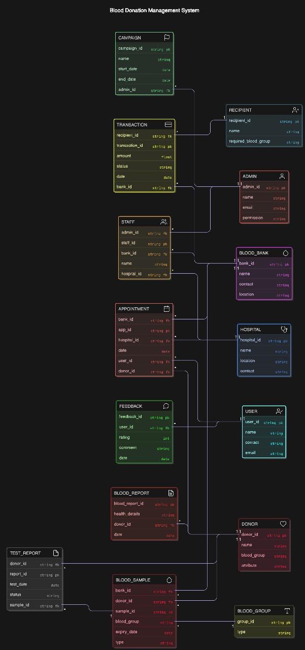
Figure 2.1: Relational Schema for blood bank management system

Creation of Database and Tables - DDL Commands

CREATE TABLE Admin (
admin_id INT PRIMARY KEY AUTO_INCREMENT, name VARCHAR(100), email VARCHAR(100), contact VARCHAR(20), permissions TEXT
);
INSERT INTO Admin (name, email,permissions) VALUES
('Rahul Sharma', 'rahul.sharma@example.com', 'Full Access'),
('Ananya Gupta', 'ananya.gupta@example.com', 'Manage Campaigns, View Reports'),
('Vikram Singh', 'vikram.singh@example.com', 'Manage Donors, View Transactions'),
('Priya Mehta', 'priya.mehta@example.com', Manage Hospitals, View Feedback'),
('Amit Verma', 'amit.verma@example.com', ''View Reports, Manage Blood Stock');
SELECT * FROM Admin;

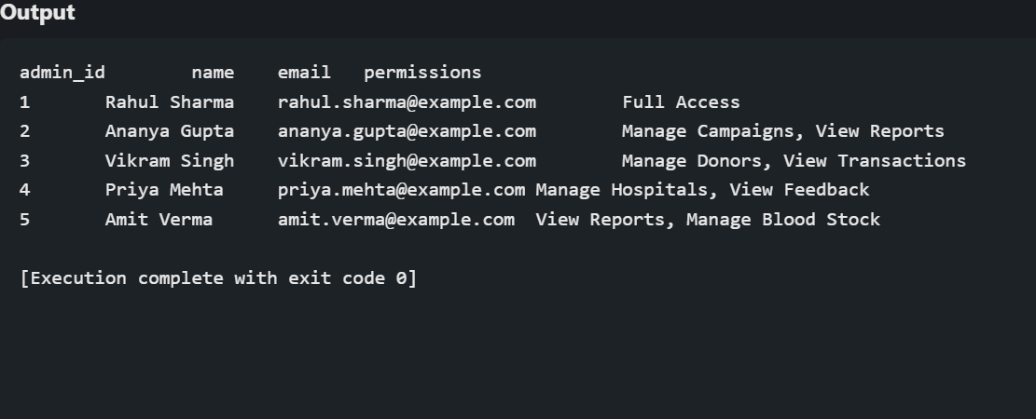

CREATE TABLE CAMPAIGN (
Campaign_id INT PRIMARY KEY,
Admin_id INT,
Name VARCHAR(100),
Start_date DATE,
End_date DATE,
FOREIGN KEY (Admin_id) REFERENCES ADMIN(Admin_id)
);
INSERT INTO CAMPAIGN VALUES
(1, 1, 'Blood Drive 2025', '2025-01-10', '2025-01-15'),
(2, 2, 'Emergency Blood Collection', '2025-02-20', '2025-02-25'),
(3, 3, 'Save Lives Initiative', '2025-03-05', '2025-03-10'),
(4, 4, 'Red Cross Support', '2025-04-12', '2025-04-17'),
(5, 5, 'Annual Blood Donation Camp', '2025-05-01', '2025-05-07');

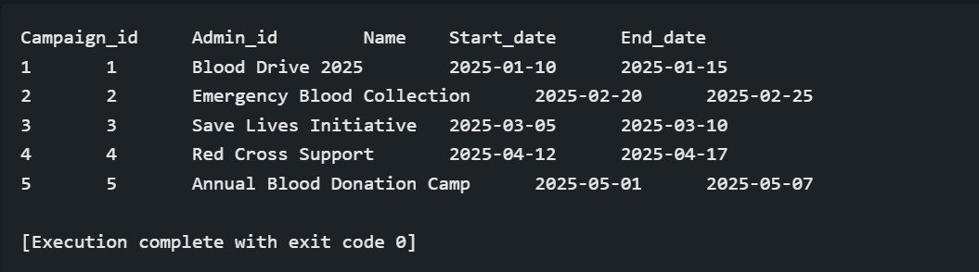

CREATE TABLE HOSPITAL (
Hospital_id INT PRIMARY KEY,
Name VARCHAR(100),
Location VARCHAR(100),
Contact VARCHAR(50)
);
INSERT INTO HOSPITAL VALUES
(1, 'City Hospital', 'Downtown', '9876543210'),
(2, 'Green Valley Clinic', 'Uptown', '8765432109'),
(3, 'Health Care Center', 'West Side', '7654321098'),
(4, 'Sunrise Medical', 'East Side', '6543210987'),
(5, 'Metro Hospital', 'Central', '5432109876');

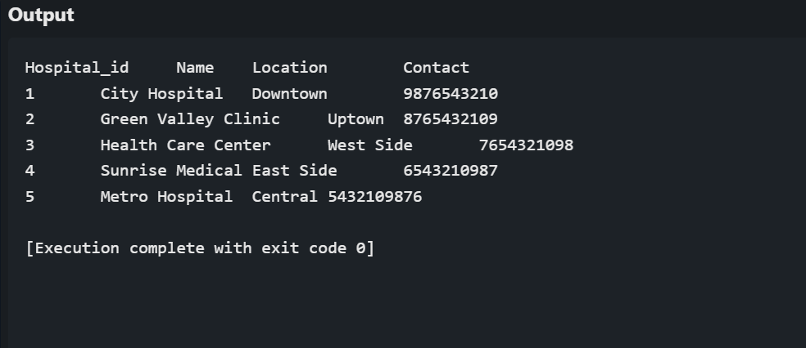

CREATE TABLE BLOOD_BANK (
Bank_id INT PRIMARY KEY,
Name VARCHAR(100),
Contact VARCHAR(50),
Location VARCHAR(100)
);
INSERT INTO BLOOD_BANK VALUES
(1, 'Red Cross Bank', '1234567890', 'Main Street'),
(2, 'Life Saver Bank', '2345678901', 'City Center'),
(3, 'Donate & Save Bank', '3456789012', 'North Zone'),
(4, 'Hope Blood Bank', '4567890123', 'South Zone'),
(5, 'Universal Blood Bank', '5678901234', 'East Zone');
SELECT * FROM BLOOD_BANK;
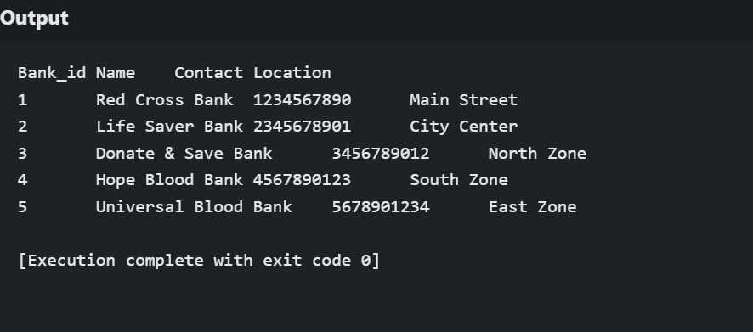

CREATE TABLE STAFF (
Staff_id INT PRIMARY KEY,
Admin_id INT,
Bank_id INT,
Hospital_id INT,
Name VARCHAR(100),
FOREIGN KEY (Admin_id) REFERENCES ADMIN(Admin_id),
FOREIGN KEY (Bank_id) REFERENCES BLOOD_BANK(Bank_id),
FOREIGN KEY (Hospital_id) REFERENCES HOSPITAL(Hospital_id)
);
INSERT INTO STAFF (Staff_id, Admin_id, Bank_id, Hospital_id, Name) VALUES
(1, 1, 1, 1, 'James Wilson'),
(2, 2, 2, 2, 'Olivia Martinez'),
(3, 3, 3, 3, 'Ethan Johnson'),
(4, 4, 4, 4, 'Sophia Hernandez'),
(5, 5, 5, 5, 'Daniel Brown');

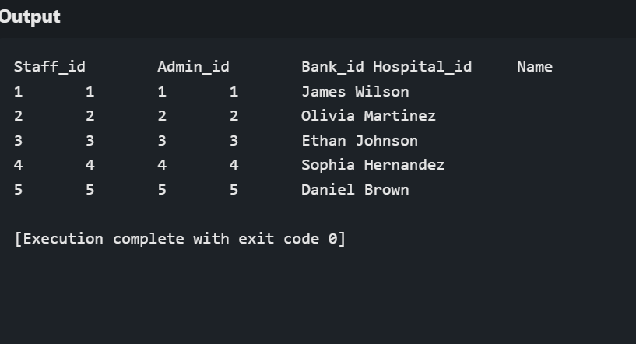

CREATE TABLE DONOR (
Donor_id INT PRIMARY KEY,
Name VARCHAR(100),
Blood_Group VARCHAR(10),
Attribute VARCHAR(100)
);
INSERT INTO DONOR VALUES
(1, 'David White', 'A+', 'Regular Donor'),
(2, 'Jessica Blue', 'O-', 'First Time Donor'),
(3, 'Samuel Green', 'B+', 'Frequent Donor'),
(4, 'Sophia Black', 'AB-', 'Emergency Donor'),
(5, 'Ryan Grey', 'O+', 'Regular Donor');
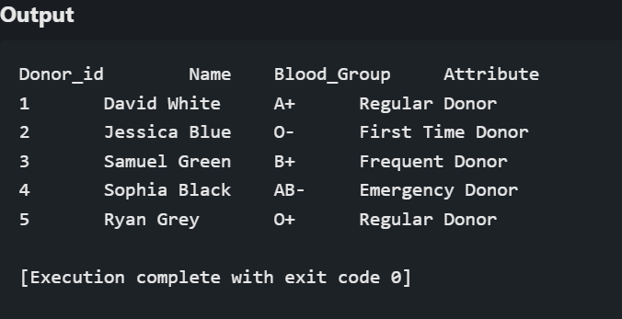
CREATE TABLE USER (
User_id INT PRIMARY KEY,
Name VARCHAR(100),
Contact VARCHAR(50),
Email VARCHAR(100)
);
INSERT INTO USER (User_id, Name, Contact, Email) VALUES
(1, 'Ava Johnson', '9876543210', 'ava.johnson@example.com'),
(2, 'Liam Smith', '8765432109', 'liam.smith@example.com'),
(3, 'Emma Brown', '7654321098', 'emma.brown@example.com'),
(4, 'Noah Williams', '6543210987', 'noah.williams@example.com'),
(5, 'Olivia Davis', '5432109876', 'olivia.davis@example.com');

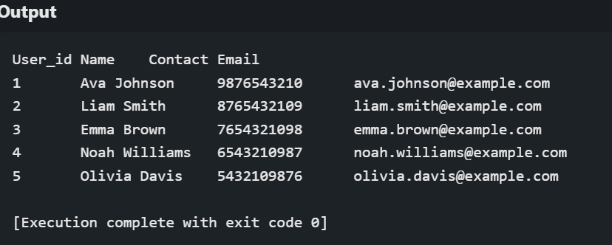

CREATE TABLE RECIPIENT (
Recipient_id INT PRIMARY KEY,
Name VARCHAR(100),
Required_blood_group VARCHAR(10)
);
INSERT INTO RECIPIENT VALUES
(1, 'Tom Adams', 'A+'),
(2, 'Nancy Lee', 'O-'),
(3, 'Peter Parker', 'B+'),
(4, 'Bruce Wayne', 'AB-'),
(5, 'Clark Kent', 'O+');
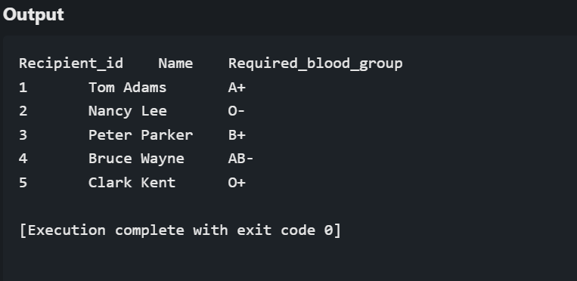

CREATE TABLE TRANSACTION (
Transaction_id INT PRIMARY KEY,
Recipient_id INT,
Bank_id INT,
Amount DECIMAL(10,2),
Status VARCHAR(50),
Date DATE,
FOREIGN KEY (Recipient_id) REFERENCES RECIPIENT(Recipient_id),
FOREIGN KEY (Bank_id) REFERENCES BLOOD_BANK(Bank_id)
);
INSERT INTO TRANSACTION VALUES
(1, 1, 1, 500.00, 'Completed', '2025-01-12'),
(2, 2, 2, 300.00, 'Pending', '2025-02-21'),
(3, 3, 3, 450.00, 'Completed', '2025-03-07'),
(4, 4, 4, 600.00, 'Cancelled', '2025-04-14'),
(5, 5, 5, 350.00, 'Completed', '2025-05-03');
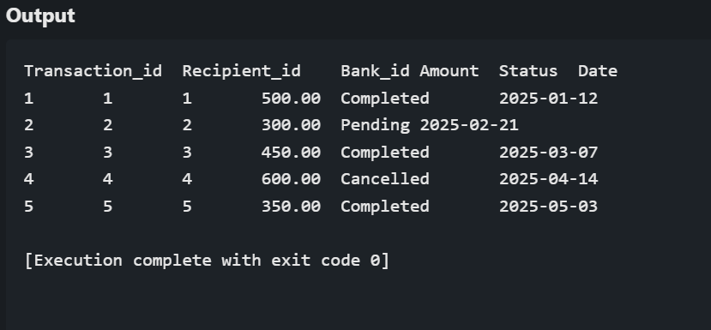
CREATE TABLE APPOINTMENT (
App_id INT PRIMARY KEY,
Donor_id INT,
User_id INT,
Bank_id INT,
Hospital_id INT,
Date DATE,
FOREIGN KEY (Donor_id) REFERENCES DONOR(Donor_id),
FOREIGN KEY (User_id) REFERENCES USER(User_id),
FOREIGN KEY (Bank_id) REFERENCES BLOOD_BANK(Bank_id),
FOREIGN KEY (Hospital_id) REFERENCES HOSPITAL(Hospital_id)
);
INSERT INTO APPOINTMENT (App_id, Donor_id, User_id, Bank_id, Hospital_id, Date) VALUES
(1, 1, 1, 1, 1, '2025-02-20'),
(2, 2, 2, 2, 2, '2025-03-15'),
(3, 3, 3, 3, 3, '2025-04-10'),
(4, 4, 4, 4, 4, '2025-05-05'),
(5, 5, 5, 5, 5, '2025-06-01');
SELECT * FROM TRANSACTION;
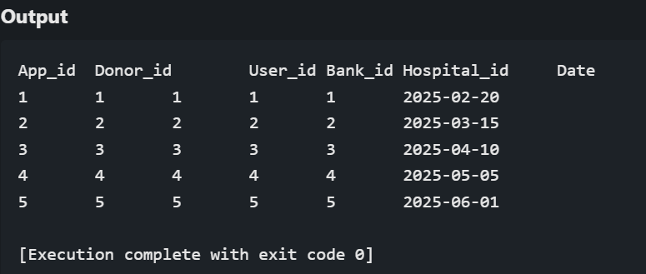
CREATE TABLE APPOINTMENT (
App_id INT PRIMARY KEY,
Donor_id INT,
User_id INT,
Bank_id INT,
Hospital_id INT,
Date DATE,
FOREIGN KEY (Donor_id) REFERENCES DONOR(Donor_id),
FOREIGN KEY (User_id) REFERENCES USER(User_id),
FOREIGN KEY (Bank_id) REFERENCES BLOOD_BANK(Bank_id),
FOREIGN KEY (Hospital_id) REFERENCES HOSPITAL(Hospital_id)
);

INSERT INTO APPOINTMENT VALUES
(1, 1, 1, 1, 1, '2025-02-20'),
(2, 2, 2, 2, 2, '2025-03-15'),
(3, 3, 3, 3, 3, '2025-04-10'),
(4, 4, 4, 4, 4, '2025-05-05'),
(5, 5, 5, 5, 5, '2025-06-01');

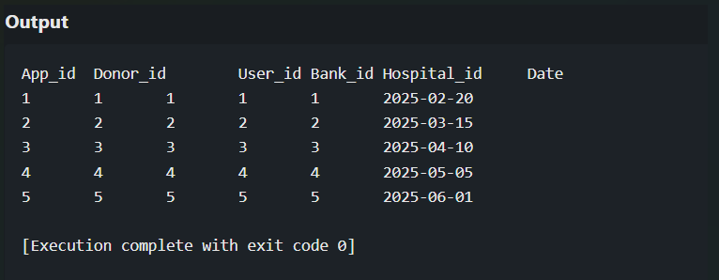
CREATE TABLE FEEDBACK (
Feedback_id INT PRIMARY KEY,
User_id INT,
Rating INT,
Comment TEXT,
Date DATE,
FOREIGN KEY (User_id) REFERENCES USER(User_id)
);
INSERT INTO FEEDBACK VALUES
(1, 1, 5, 'Great experience, very organized.', '2025-02-22'),
(2, 2, 4, 'Good service but needs improvement.', '2025-03-17'),
(3, 3, 5, 'Excellent staff and management.', '2025-04-12'),
(4, 4, 3, 'Average experience, long waiting time.', '2025-05-07'),
(5, 5, 5, 'Highly recommend this facility.', '2025-06-03');
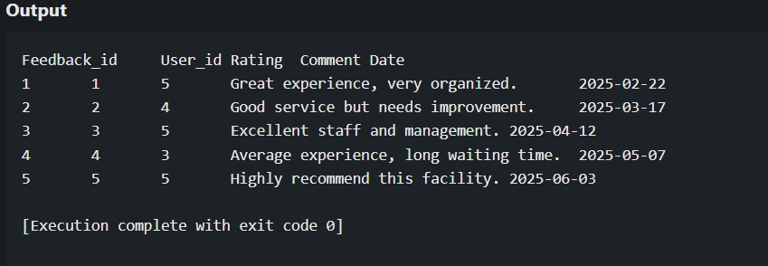
CREATE TABLE BLOOD_REPORT (
Blood_Report_id INT PRIMARY KEY,
Donor_id INT,
Health_Details TEXT,
Date DATE,
FOREIGN KEY (Donor_id) REFERENCES DONOR(Donor_id)
);

INSERT INTO BLOOD_REPORT VALUES
(1, 1, 'Healthy donor, no infections.', '2025-02-21'),
(2, 2, 'Low hemoglobin, advised supplements.', '2025-03-16'),
(3, 3, 'Blood sugar levels normal.', '2025-04-11'),
(4, 4, 'Mild dehydration noted.', '2025-05-06'),
(5, 5, 'All health parameters are normal.', '2025-06-02');

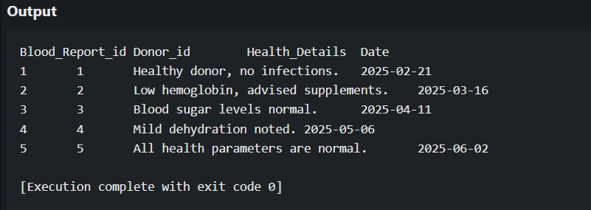

CREATE TABLE TEST_REPORT (
Report_id INT PRIMARY KEY,
Donor_id INT,
Sample_id INT,
Test_date DATE,
Status VARCHAR(50),
FOREIGN KEY (Donor_id) REFERENCES DONOR(Donor_id),
FOREIGN KEY (Sample_id) REFERENCES BLOOD_SAMPLE(Sample_id)
);

INSERT INTO TEST_REPORT VALUES
(1, 1, 1, '2025-02-22', 'Passed'),
(2, 2, 2, '2025-03-18', 'Failed - Low RBC count'),
(3, 3, 3, '2025-04-13', 'Passed'),
(4, 4, 4, '2025-05-08', 'Passed'),
(5, 5, 5, '2025-06-04', 'Failed - Infection detected');
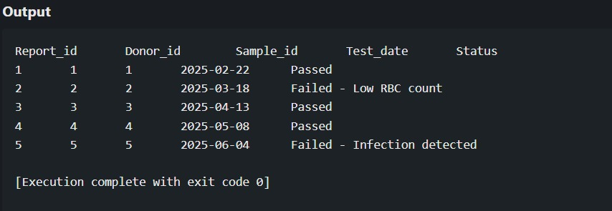

CREATE TABLE BLOOD_SAMPLE (
Sample_id INT PRIMARY KEY,
Donor_id INT,
Bank_id INT,
Blood_group VARCHAR(10),
Expiry_date DATE,
Type VARCHAR(50),
FOREIGN KEY (Donor_id) REFERENCES DONOR(Donor_id),
FOREIGN KEY (Bank_id) REFERENCES BLOOD_BANK(Bank_id)
);

INSERT INTO BLOOD_SAMPLE VALUES
(1, 1, 1, 'A+', '2025-05-22', 'Whole Blood'),
(2, 2, 2, 'O-', '2025-06-18', 'Plasma'),
(3, 3, 3, 'B+', '2025-07-13', 'Red Blood Cells'),
(4, 4, 4, 'AB-', '2025-08-08', 'Platelets'),
(5, 5, 5, 'O+', '2025-09-04', 'Plasma');

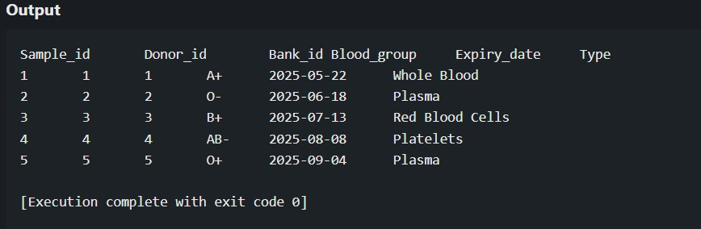

CREATE TABLE MANAGES (
Admin_id INT,
Campaign_id INT,
PRIMARY KEY (Admin_id, Campaign_id),
FOREIGN KEY (Admin_id) REFERENCES ADMIN(Admin_id),
FOREIGN KEY (Campaign_id) REFERENCES CAMPAIGN(Campaign_id)
);
-- Insert Data into MANAGES
INSERT INTO MANAGES VALUES
(1, 101),
(2, 102),
(3, 103),
(4, 104),
(5, 105);
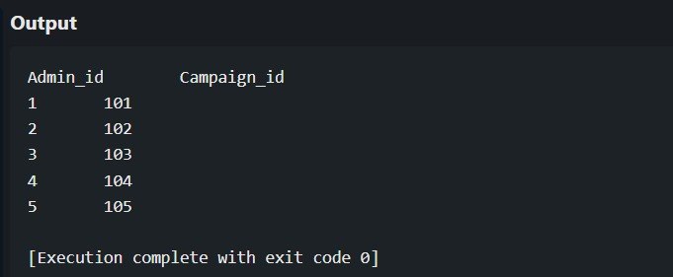

-- Creating TRANSACTION Table
CREATE TABLE TRANSACTION (
Transaction_id INT PRIMARY KEY,
Recipient_id INT,
Bank_id INT,
Amount DECIMAL(10,2),
Status VARCHAR(50),
Date DATE,
FOREIGN KEY (Recipient_id) REFERENCES RECIPIENT(Recipient_id) ON DELETE CASCADE,
FOREIGN KEY (Bank_id) REFERENCES BLOOD_BANK(Bank_id) ON DELETE CASCADE
);

-- Inserting Data into TRANSACTION (After RECIPIENT and BLOOD_BANK)
INSERT INTO TRANSACTION VALUES
(1, 1, 1, 500.00, 'Completed', '2025-02-10'),
(2, 2, 2, 1000.00, 'Pending', '2025-03-12'),
(3, 3, 3, 750.00, 'Failed', '2025-04-14'),
(4, 4, 4, 1200.00, 'Completed', '2025-05-16')
(5, 5, 5, 300.00, 'Pending', '2025-06-18');

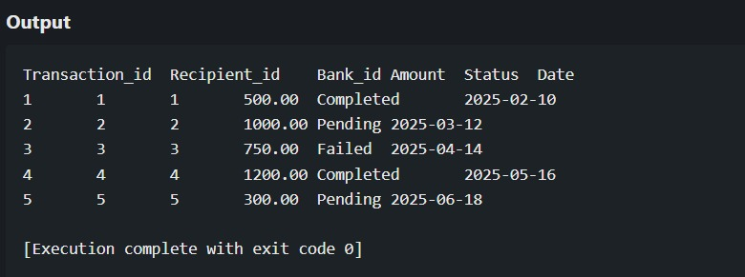
-- Creating APPOINTMENT Table
CREATE TABLE APPOINTMENT (
App_id INT PRIMARY KEY,
Donor_id INT,
User_id INT,
Bank_id INT,
Hospital_id INT,
Date DATE,
FOREIGN KEY (Donor_id) REFERENCES DONOR(Donor_id),
FOREIGN KEY (User_id) REFERENCES USER(User_id),
FOREIGN KEY (Bank_id) REFERENCES BLOOD_BANK(Bank_id),
FOREIGN KEY (Hospital_id) REFERENCES HOSPITAL(Hospital_id)
);

-- Inserting Data into APPOINTMENT
INSERT INTO APPOINTMENT VALUES
(1, 1, 1, 1, 1, '2025-02-15'),
(2, 2, 2, 2, 2, '2025-03-20'),
(3, 3, 3, 3, 3, '2025-04-25'),
(4, 4, 4, 4, 4, '2025-05-30'),
(5, 5, 5, 5, 5, '2025-06-10');

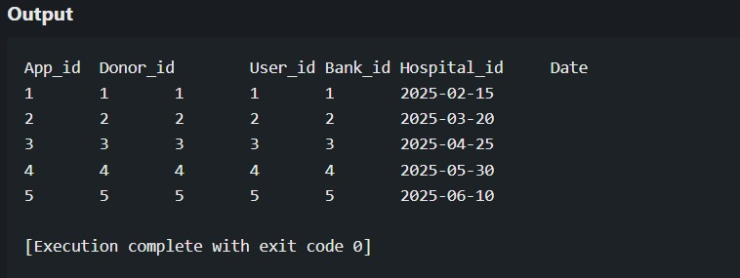

-- Creating BLOOD_SAMPLE Table
CREATE TABLE BLOOD_SAMPLE (
Sample_id INT PRIMARY KEY,
Donor_id INT,
Bank_id INT,
Blood_group VARCHAR(10),
Quantity INT, -- Added Quantity column
Expiry_date DATE,
Type VARCHAR(50),
FOREIGN KEY (Donor_id) REFERENCES DONOR(Donor_id),
FOREIGN KEY (Bank_id) REFERENCES BLOOD_BANK(Bank_id)
);

-- Inserting Data into BLOOD_SAMPLE
INSERT INTO BLOOD_SAMPLE (Sample_id, Donor_id, Bank_id, Blood_group, Quantity, Expiry_date, Type) VALUES
(1, 1, 1, 'A+', 500, '2025-06-01', 'Whole Blood'),
(2, 2, 2, 'O-', 300, '2025-06-05', 'Plasma'),
(3, 3, 3, 'B+', 450, '2025-06-10', 'Platelets'),
(4, 4, 4, 'AB-', 600, '2025-06-15', 'Red Blood Cells'),
(5, 5, 5, 'O+', 350, '2025-06-20', 'Whole Blood');

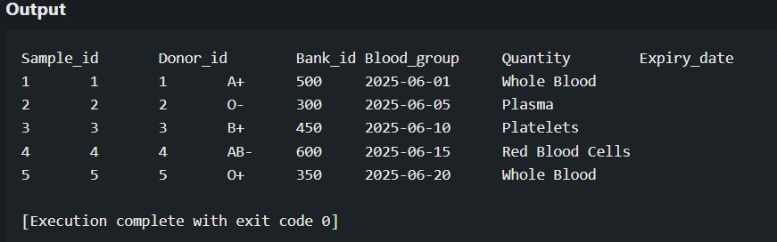

TRIGGERS
- DELIMITER $$
CREATE TRIGGER trg_format_admin_name
BEFORE INSERT ON Admin
FOR EACH ROW
BEGIN
SET NEW.name = UPPER(NEW.name);
END$$
DELIMITER ;
INSERT INTO Admin (name, email, contact, permissions)
VALUES ('Sneha Rao', 'sneha.rao@example.com', '9871234567', 'View Reports');
SELECT * FROM Admin WHERE email = 'sneha.rao@example.com';
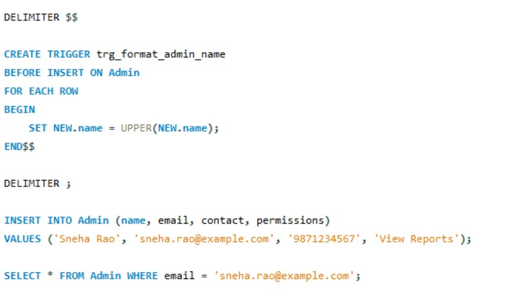
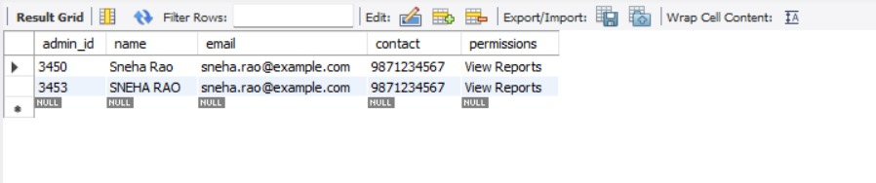

2. DELIMITER $$

CREATE TRIGGER trg_format_campaign_name
BEFORE INSERT ON Campaign
FOR EACH ROW
BEGIN
SET NEW.name = UPPER(NEW.name);
END$$

DELIMITER ;

INSERT INTO Campaign VALUES (106, 2, 'summer health drive', '2025-07-01', '2025-07-07');
SELECT * FROM Campaign WHERE campaign_id = 106;
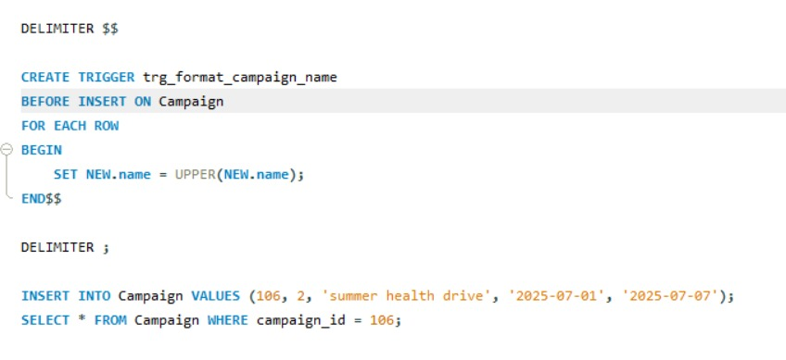
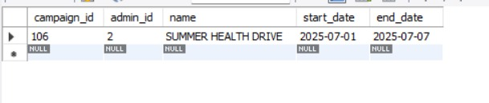
3. DELIMITER $$
CREATE TRIGGER trg_format_hospital_data
BEFORE INSERT ON Hospital
FOR EACH ROW
BEGIN
-- Format hospital name to uppercase
SET NEW.name = UPPER(NEW.name);

-- Check if contact number is 10 digits
IF CHAR_LENGTH(NEW.contact) != 10 THEN
SIGNAL SQLSTATE '45000'
SET MESSAGE_TEXT = 'Contact number must be exactly 10 digits';
END IF;
END$$

DELIMITER ;

INSERT INTO Hospital (hospital_id, name, location, contact)
VALUES (6, 'Lotus Care', 'North Side', '9876543210');
SELECT * FROM Hospital;
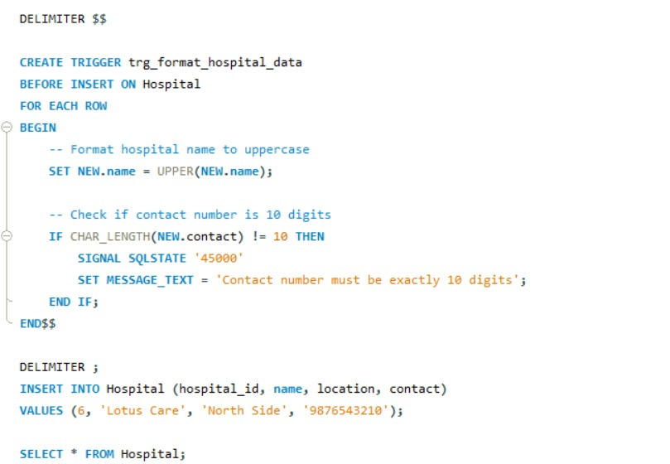

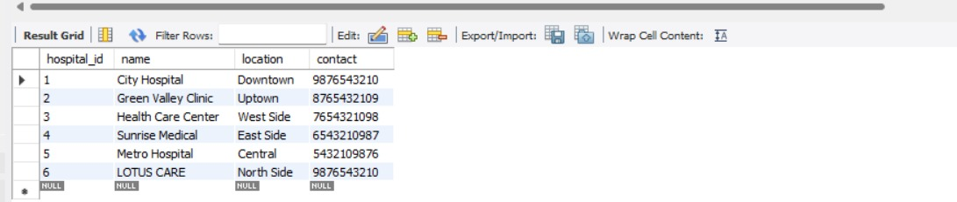
4. DELIMITER $$

CREATE TRIGGER trg_format_blood_bank_name
BEFORE INSERT ON Blood_Bank
FOR EACH ROW
BEGIN
SET NEW.name = UPPER(NEW.name);
END$$

DELIMITER ;
INSERT INTO Blood_Bank (bank_id, name, contact, location)
VALUES (6, 'life savers bank', '9123456789', 'North Wing');SELECT * FROM Blood_Bank WHERE bank_id = 6;
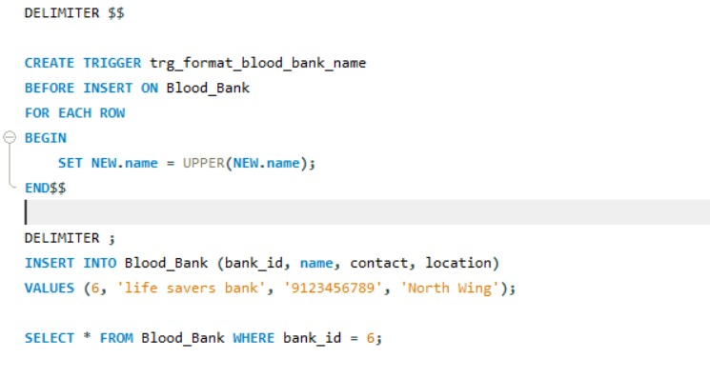
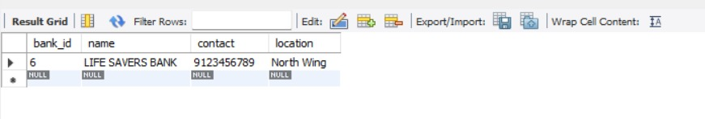

5. DELIMITER $$

CREATE TRIGGER trg_format_staff_name
BEFORE INSERT ON Staff
FOR EACH ROW
BEGIN
SET NEW.name = UPPER(NEW.name);
END$$

DELIMITER ;
INSERT INTO Staff (staff_id, admin_id, bank_id, hospital_id, name)
VALUES (6, 1, 1, 1, 'alex carter');
SELECT * FROM Staff WHERE staff_id = 6;

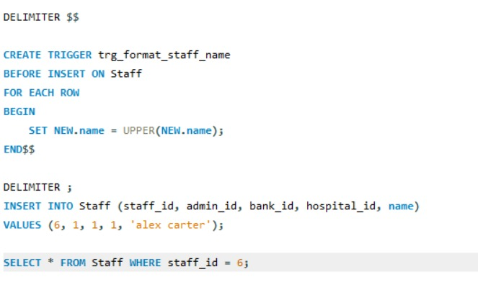

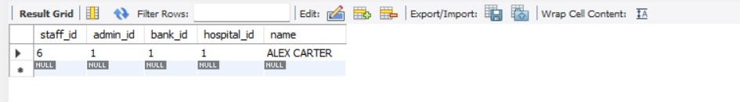

6.
DELIMITER $$
CREATE TRIGGER trg_format_donor_namedonor
BEFORE INSERT ON Donor
FOR EACH ROW
BEGIN
SET NEW.name = UPPER(NEW.name);
END$$

DELIMITER ;
INSERT INTO Donor (donor_id, name, blood_group, attribute)
VALUES (6, 'maria fernandez', 'B-', 'First Time Donor');
SELECT * FROM Donor WHERE donor_id = 6;

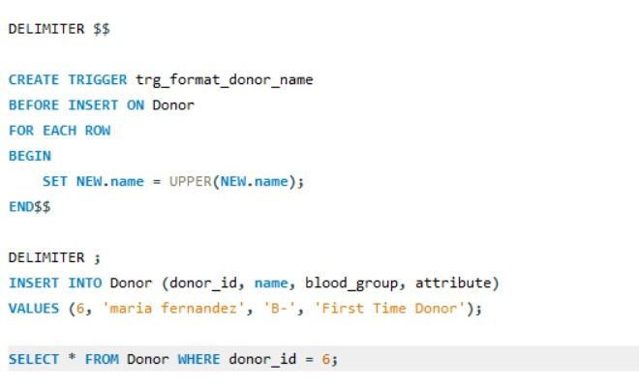

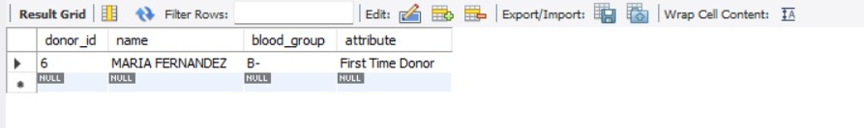
VIEWS
1. CREATE VIEW user_info_view_with_join AS
SELECT
u.user_id,
u.name AS user_name,
u.email,
u.contact
FROM
User u
JOIN
Appointment a ON u.user_id = a.user_id;

SELECT * FROM user_info_view_with_join;
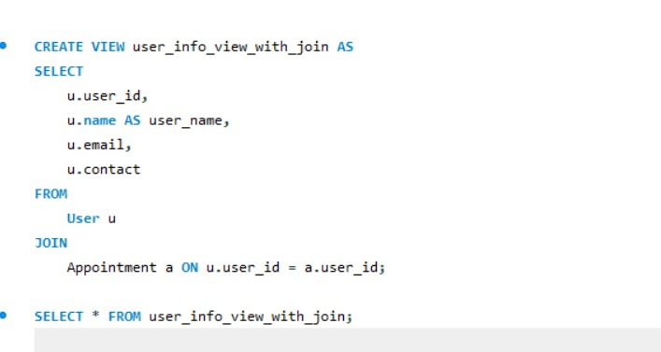
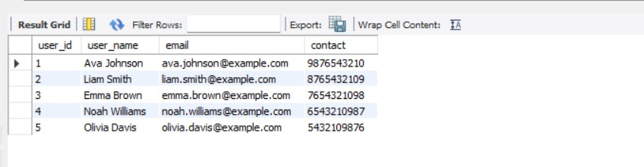
2. CREATE VIEW recipient_info_view_with_transaction AS
SELECT
r.recipient_id,
r.name AS recipient_name,
r.required_blood_group,
t.transaction_id,
t.amount,
t.status,
t.date,
b.name AS bank_name
FROM
Recipient r
JOIN
Transaction t ON r.recipient_id = t.recipient_id
JOIN
Blood_Bank b ON t.bank_id = b.bank_id;
SELECT * FROM recipient_info_view_with_transaction;

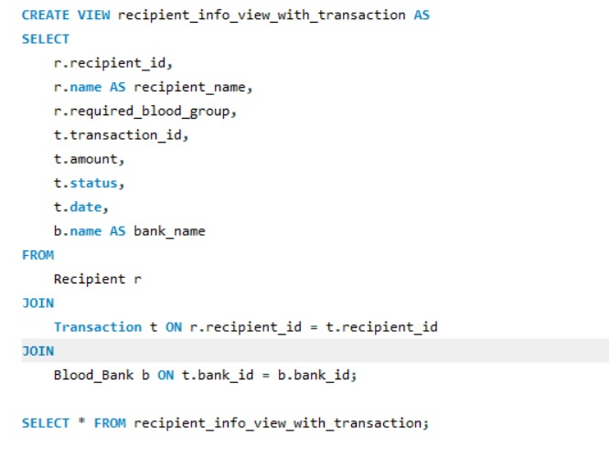

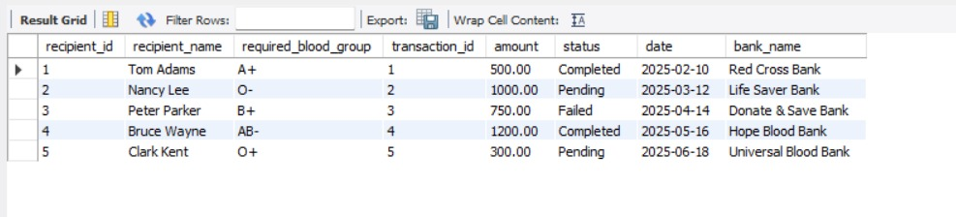

3.
CREATE VIEW transaction_details_view AS
SELECT
t.transaction_id,
r.name AS recipient_name,
r.required_blood_group,
b.name AS blood_bank_name,
t.amount,
t.status,
t.date
FROM
Transaction t
JOIN
Recipient r ON t.recipient_id = r.recipient_id
JOIN
Blood_Bank b ON t.bank_id = b.bank_id;
SELECT * FROM transaction_details_view;

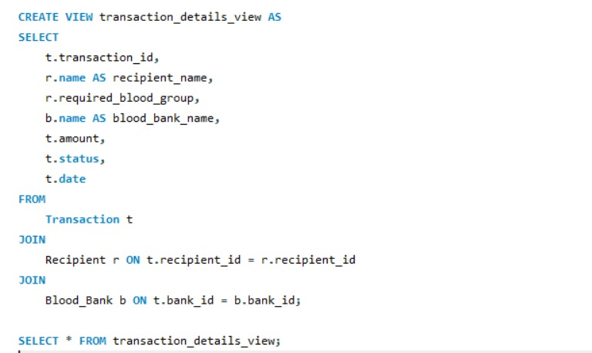
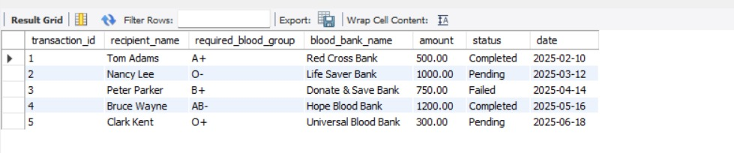

4.
CREATE VIEW appointment_details_view AS
SELECT
a.app_id,
d.name AS donor_name,
u.name AS user_name,
b.name AS blood_bank_name,
h.name AS hospital_name,
a.date AS appointment_date
FROM
Appointment a
JOIN
Donor d ON a.donor_id = d.donor_id
JOIN
User u ON a.user_id = u.user_id
JOIN
Blood_Bank b ON a.bank_id = b.bank_id
JOIN
Hospital h ON a.hospital_id = h.hospital_id;

SELECT * FROM appointment_details_view;
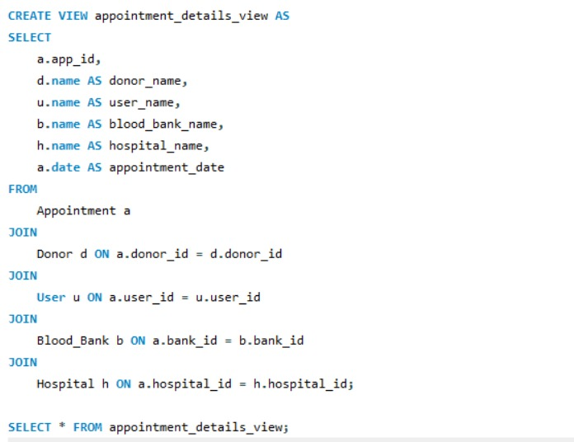
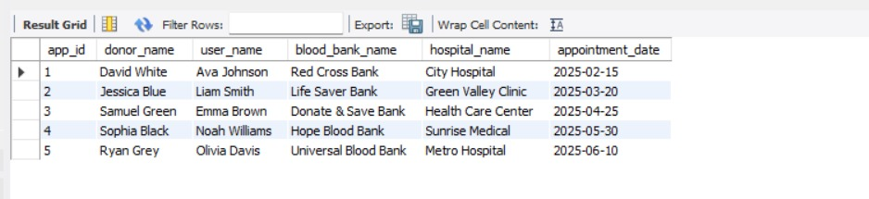

5.
CREATE VIEW user_feedback_view AS
SELECT
f.feedback_id,
u.user_id,
u.name AS user_name,
u.email,
f.rating,
f.comment,
f.date AS feedback_date
FROM
Feedback f
JOIN
User u ON f.user_id = u.user_id;

SELECT * FROM user_feedback_view;

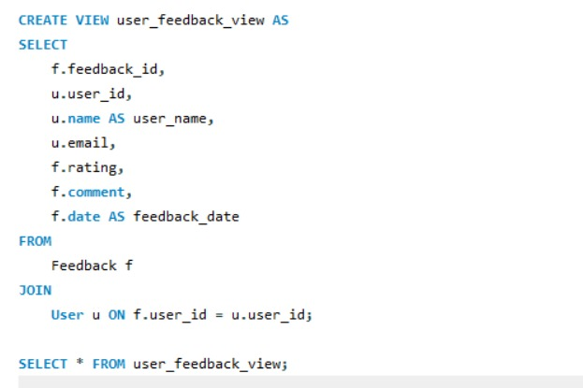

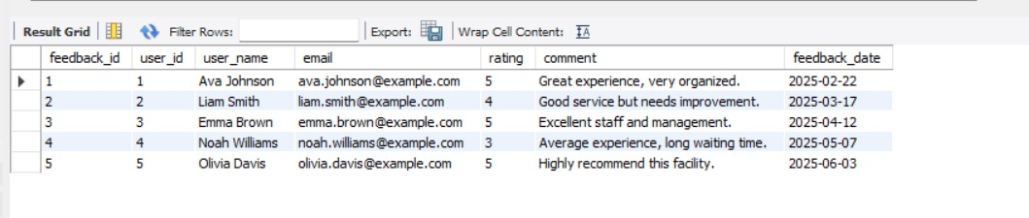

6. CREATE VIEW donor_blood_report_view AS
SELECT
br.blood_report_id,
d.donor_id,
d.name AS donor_name,
d.blood_group,
br.health_details,
br.date AS report_date
FROM
Blood_Report br
JOIN
Donor d ON br.donor_id = d.donor_id;
SELECT * FROM donor_blood_report_view;
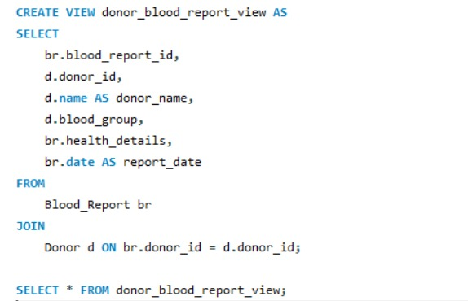

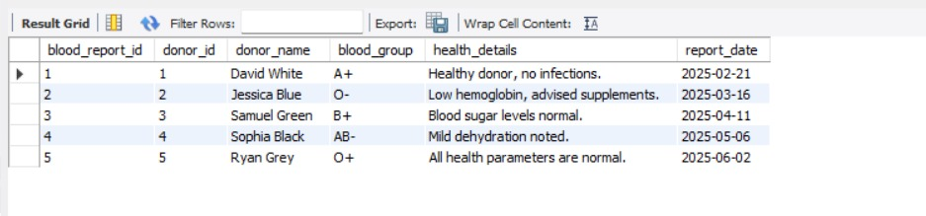

CURSORS

1.
DELIMITER $$
CREATE PROCEDURE SimpleAppointmentCursor()
BEGIN
DECLARE done INT DEFAULT FALSE;
DECLARE app_id INT;
DECLARE app_date DATE;

DECLARE cur CURSOR FOR
SELECT app_id, date FROM Appointment;

DECLARE CONTINUE HANDLER FOR NOT FOUND SET done = TRUE;

OPEN cur;
read_loop: LOOP
FETCH cur INTO app_id, app_date;

IF done THEN
LEAVE read_loop;
END IF;

SELECT CONCAT('Appointment ID: ', app_id, ', Date: ', app_date) AS Info;
END LOOP;
CLOSE cur;
END$$
DELIMITER ;
CALL SimpleAppointmentCursor();SELECT CONCAT_WS(', ', 'Appointment ID: ' , app_id, 'Date: ', date) AS Info FROM Appointment;

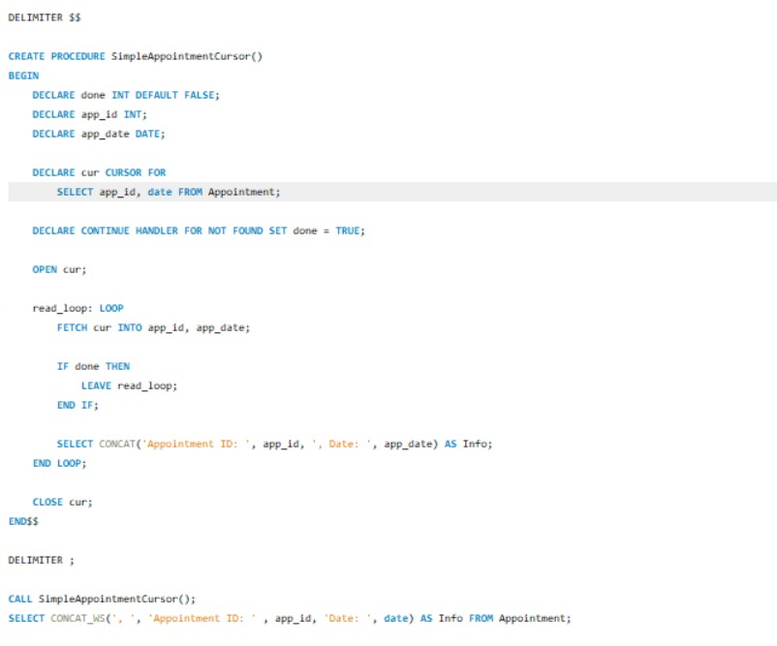

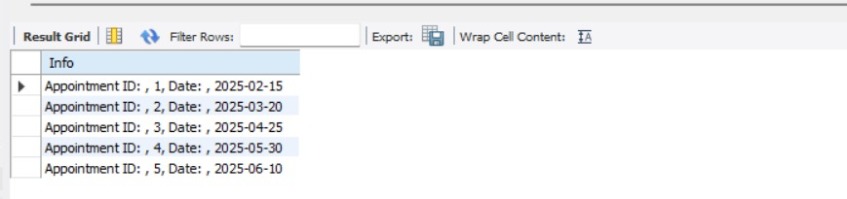

2. DELIMITER //

CREATE PROCEDURE fetch_blood_samples()

BEGIN

DECLARE done INT DEFAULT FALSE;
DECLARE sample_id INT;
DECLARE blood_type VARCHAR(10);
DECLARE sample_cursor CURSOR FOR
SELECT sample_id, blood_type FROM Blood_Sample;
DECLARE CONTINUE HANDLER FOR NOT FOUND SET done = TRUE;
OPEN sample_cursor;
read_loop: LOOP
FETCH sample_cursor INTO sample_id, blood_type;
IF done THEN
LEAVE read_loop;
END IF;
SELECT CONCAT('Sample ID: ', sample_id, ', Blood Type: ', blood_type) AS Info;
END LOOP;
CLOSE sample_cursor;

END;

DELIMITER ;
CALL fetch_blood_samples();
SELECT CONCAT('Sample ID: ', sample_id) AS Info FROM Blood_Sample;
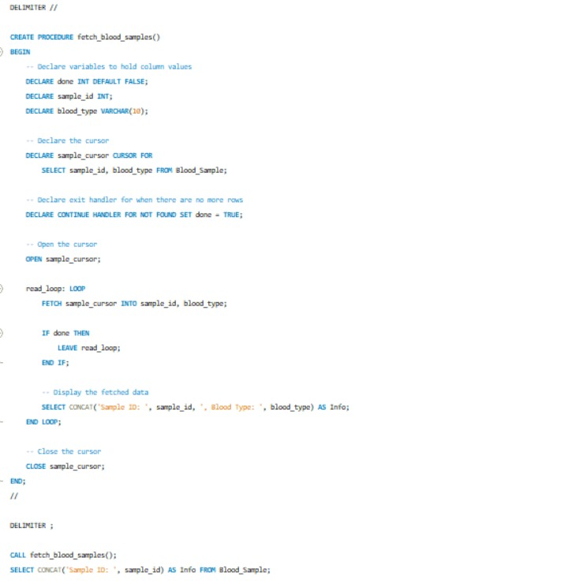

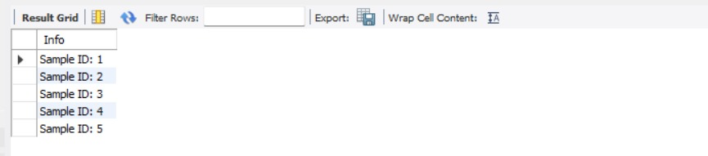

3.
DELIMITER //
CREATE PROCEDURE simple_test_report_cursor()
BEGIN
DECLARE done INT DEFAULT FALSE;
DECLARE report_id INT;
DECLARE test_type VARCHAR(100);

DECLARE cur CURSOR FOR
SELECT report_id, test_type FROM test_report;
DECLARE CONTINUE HANDLER FOR NOT FOUND SET done = TRUE;
OPEN cur;
read_loop: LOOP
FETCH cur INTO report_id, test_type;
IF done THEN
LEAVE read_loop;
END IF;

SELECT CONCAT('Report ID: ', report_id, ', Test Type: ', test_type) AS info;
END LOOP;
CLOSE cur;
END //
DELIMITER ;

CALL simple_test_report_cursor();
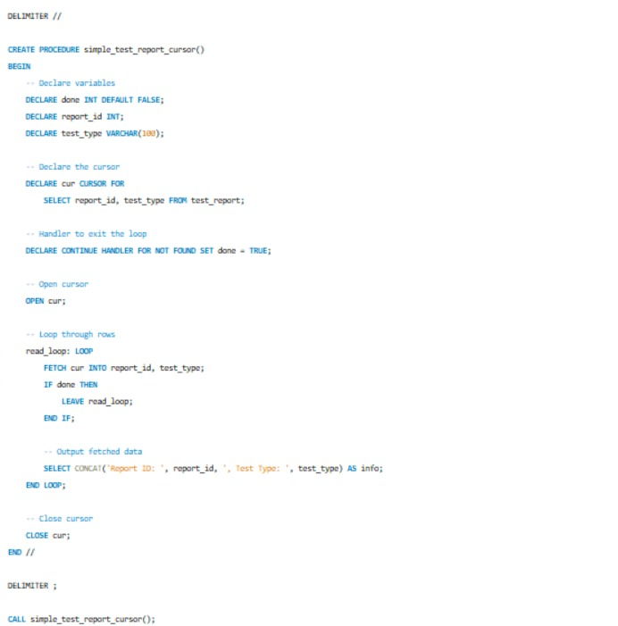

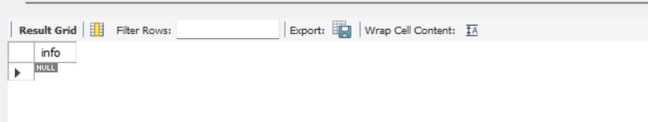
4.
DELIMITER $$

CREATE PROCEDURE SimpleTransactionCursor()
BEGIN
DECLARE done INT DEFAULT FALSE;
DECLARE trans_id INT;

DECLARE cur CURSOR FOR
SELECT trans_id FROM Transaction;

DECLARE CONTINUE HANDLER FOR NOT FOUND SET done = TRUE;
-- Open the cursor
OPEN cur;

read_loop: LOOP
FETCH cur INTO trans_id;
IF done THEN
LEAVE read_loop;
END IF;

SELECT CONCAT('Processing Transaction ID: ', trans_id);
END LOOP;
CLOSE cur;
END$$

DELIMITER ;
CALL SimpleTransactionCursor();
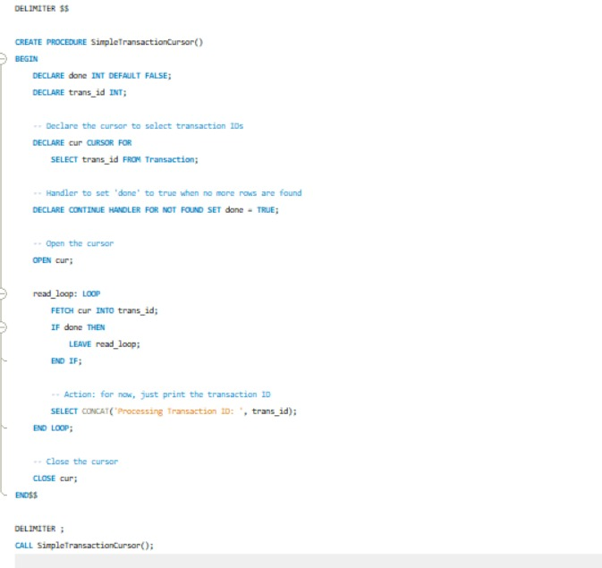

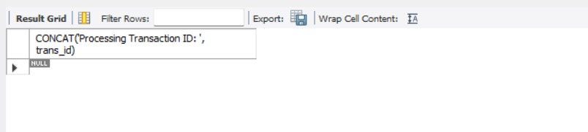

5.

DELIMITER $$
CREATE PROCEDURE FeedbackCursor()
BEGIN
DECLARE done INT DEFAULT FALSE;
DECLARE feedback_id INT;
DECLARE cur CURSOR FOR
SELECT feedback_id FROM Feedback;
DECLARE CONTINUE HANDLER FOR NOT FOUND SET done = TRUE;
OPEN cur;

read_loop: LOOP
FETCH cur INTO feedback_id;
IF done THEN
LEAVE read_loop;
END IF;
SELECT CONCAT('Reading Feedback ID: ', feedback_id);
END LOOP;

CLOSE cur;
END$$
DELIMITER ;
CALL FeedbackCursor();
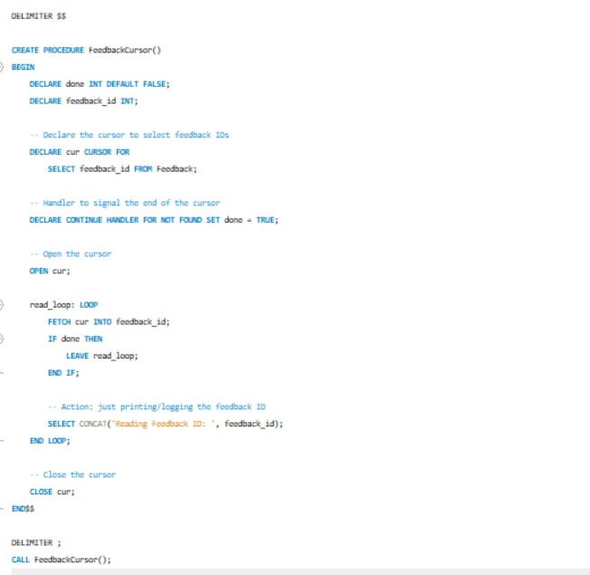

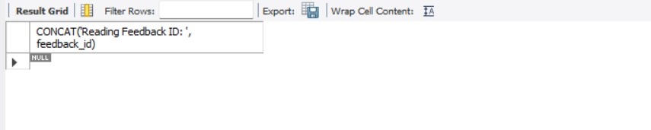
SETS

1.
SELECT donor_id AS person_id, 'Donor' AS role
FROM Appointment
WHERE hospital_id = 1
UNION
-- Users with appointments at Blood Bank 1
SELECT user_id AS person_id, 'User' AS role
FROM Appointment
WHERE bank_id = 1;
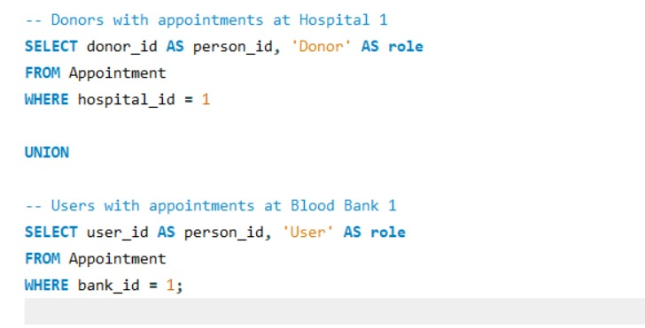
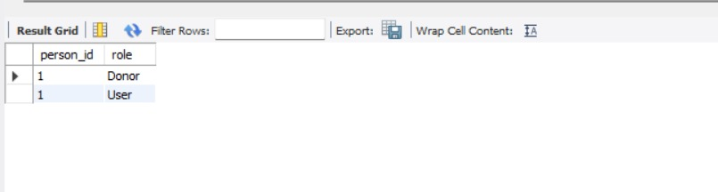

2.
SELECT admin_id AS person_id, 'Blood Bank Admin' AS role
FROM Admin
WHERE assigned_bank_id = 1

UNION

SELECT admin_id AS person_id, 'Campaign Admin' AS role
FROM Admin

WHERE assigned_campaign_id = 1;

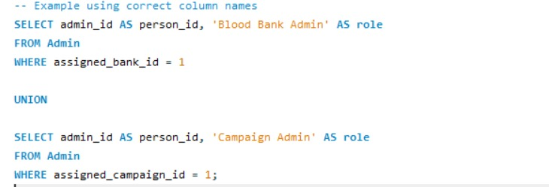

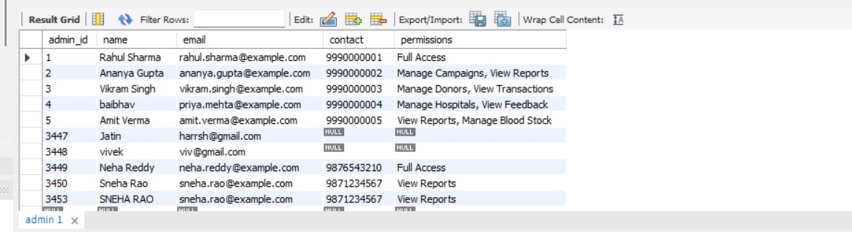

3.
SELECT sample_id, 'Group A+' AS category
FROM Blood_Sample
WHERE blood_group = 'A+'
UNION
-- Blood Samples stored in Blood Bank 1
SELECT sample_id, 'Stored at Blood Bank 1' AS category
FROM Blood_Sample
WHERE bank_id = 1;
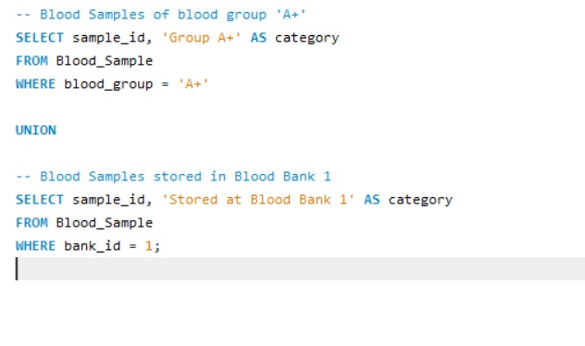
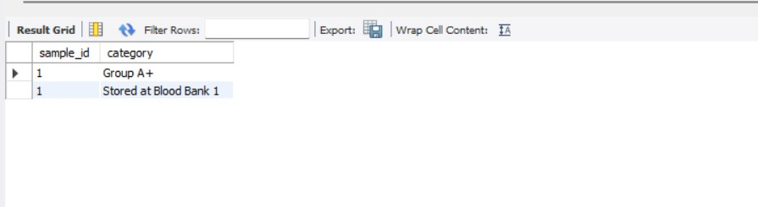
4.
SELECT admin_id FROM Manages WHERE campaign_id % 2 = 0 -- Even campaign IDs
UNION
SELECT admin_id FROM Manages WHERE campaign_id % 2 = 1; -- Odd campaign IDs

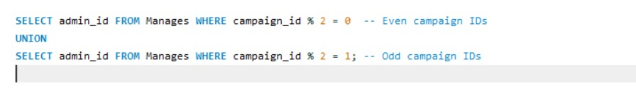

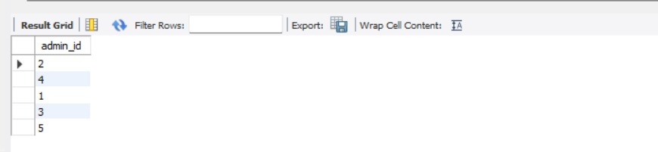

5.
SELECT donor_id FROM Blood_Sample WHERE type = 'Whole Blood'
UNION
SELECT donor_id FROM Blood_Sample WHERE type = 'Plasma';

